Large Fibonacci Number Calculator Using Arrays

Trevor Parsons

Function (C++):

int main()

{

int N = 0;

int x[100];

int y[100];

int z[100];

int count = 2;

bool digits = false;

bool isZero = true;

cout << "Enter a positive integer value for N: ";

cin >> N;

for (int i = 0; i < 100; i++)

{

x[i] = NULL;

y[i] = NULL;

z[i] = NULL;

}

x[99] = 0;

y[99] = 1;

if (N == 0)

{

cout << 0;

}

else if (N == 1)

{

cout << 1;

}

else

{

int remainder = 0;

while (count < N - 1)

{

for (int i = 99; i >= 0; i--)

{

z[i] = (remainder + x[i] + y[i]) % 10;

if ((z[0] != NULL) && (z[0] != 0))

{

cout << "\n\nERROR: 100 digits reached." << endl << endl;

cout << "Largest Fibonacci number less than 100 digits is F("

<< count - 1 << "), shown above.";

digits = true;

break;

}

remainder = (remainder + x[i] + y[i]) / 10;

}

if (digits == true)

{

break;

}

for (int i = 99; i >= 0; i--)

{

x[i] = y[i];

y[i] = z[i];

}

cout << "F(" << count << "): ";

for (int j = 0; j < 100; j++)

{

if (z[j] != 0)

isZero = false;

if (isZero == false)

cout << z[j];

}

isZero = true;

count++;

cout << endl;

}

z[0] = remainder;

}

cout << endl << endl;

system("pause");

return 0;

}

(Example output on next page)

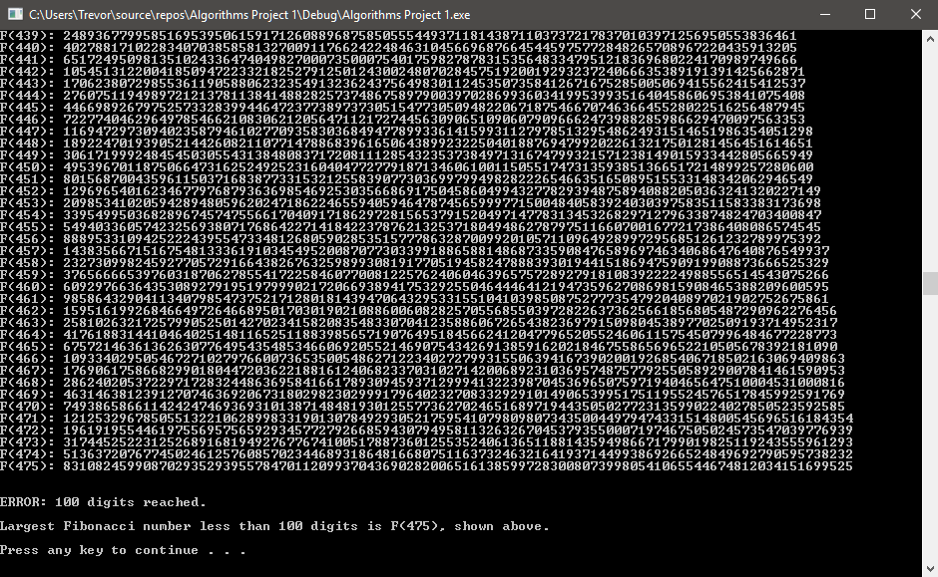Example Output (N = 500):